module decade_counter ( output reg [3:0] q,

input clk );

initial

q=4'h0;

always @(posedge clk)

q <= q == 9 ? 0 : q + 1;

endmodule

module tb_decade_counter();

wire[3:0] q;

reg clk;

integer i;

decade_counter UUT(q,clk);

initial

begin

$monitor("clk = ", clk, ", q = %b", q);

for (i=0; i<=20; i=i+1)

begin

clk=1;

#5;

clk=0;

#5

$display("\n\n");

end

end

endmodule

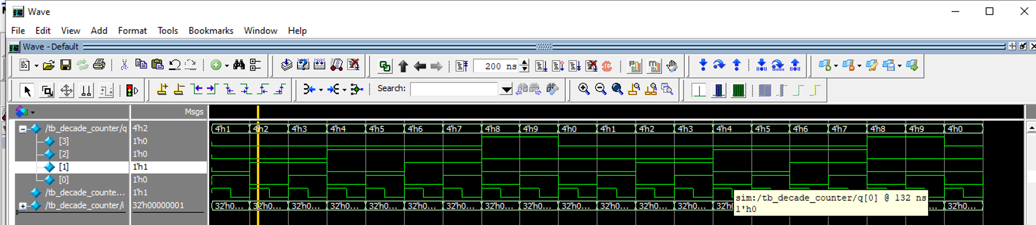

module decoded_counter ( output ctrl,

input clk );

reg [3:0] count_value;

initial

count_value=4'hF;

always @(posedge clk)

count_value <= count_value + 1;

assign ctrl = count_value == 4'b0111 ||

count_value == 4'b1011;

endmodule

module tb_decoded_counter();

wire ctrl;

reg clk;

integer i;

decoded_counter UUT(ctrl, clk);

initial

begin

$monitor("ctrl = ", ctrl, ", clk = ", clk);

for (i=0; i<=15; i=i+1)

begin

clk=1;

#5;

clk=0;

#5;

$display("\n\n");

end

end

endmodule

